SDLC: Software development life cycle:

Waterfall Model:

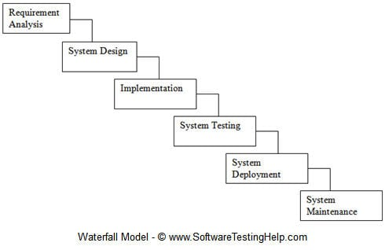

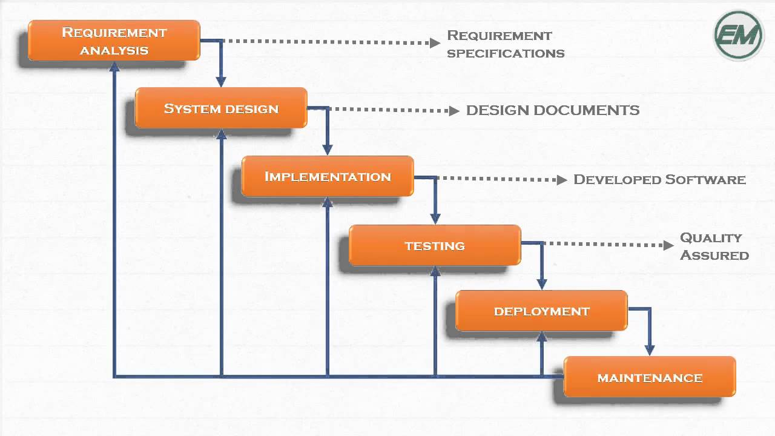

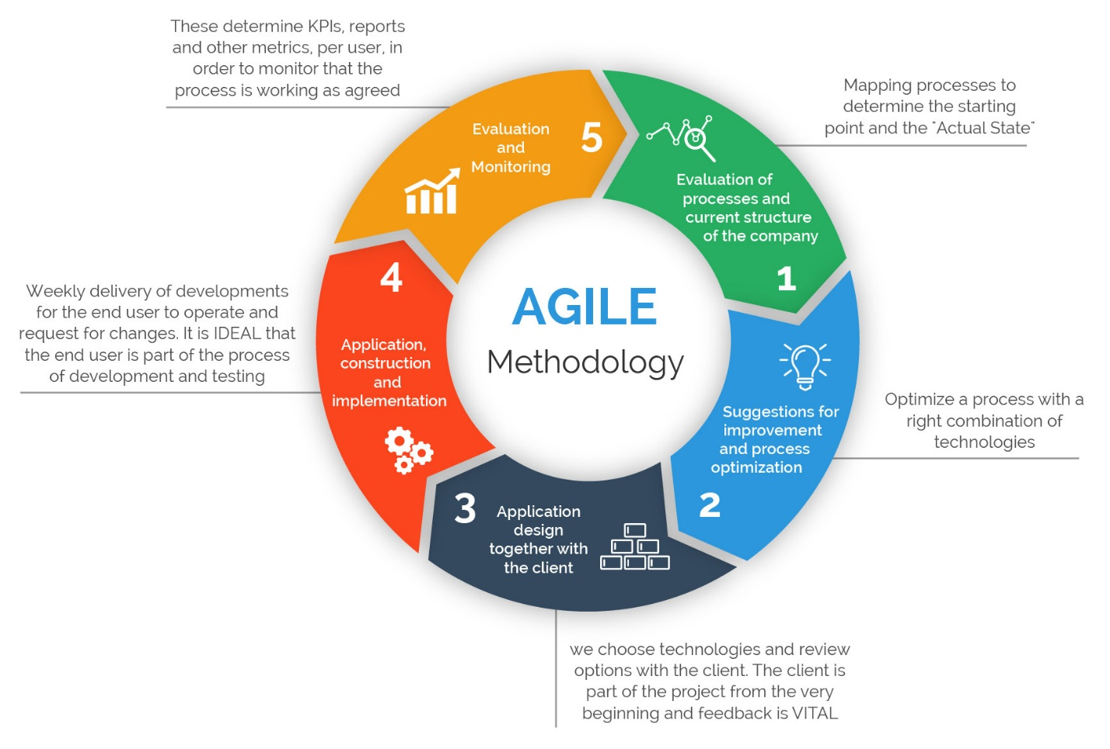Agile Methodology :

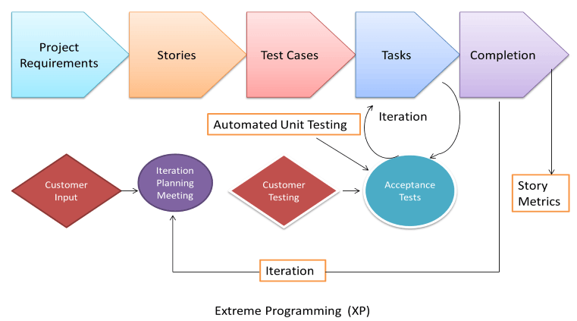

System Integrated:

DevOps:

DevOps is the set of practises, where development and engineers participate together in the entire application life cycle, from design, development, testing and finally to the production support.

DevOps is not a tool. Its is an approach and it is a culture with objective of sdlc by bringing developer and operation closer.

It emphasize communication, collaboration and integration between developers and IT operations personnel.

Its DevOps:

Management:- DevOps is the development and operation collaboration

Operation:- DevOps is treating your infrastructure as code

Developer:- DevOps is feature switches

Devops Engineer : DevOps is using automation

DevOps is small deployments.

DevOps and Agile:

DevOps is built on the concepts of Agile methodology

It identifies the importance of extending agile principle beyond development by including operations and all other functions that supports application development life cycle.

It is more than the convergence of Development + operations. It is getting involved in all the phases of software development including governance, Quality Assusrance(QA), testing, security and release management.

How DevOps Works:

Code is written in very small chunks vs large builds

Developments happen in days/hrs vs weeks/months

Development environment is identical to production

Rapid iteration improves speed to react to market needs

Developing Configuration Management Code to build infrastructure at Scale

Realtime Application performance Monitering to know the impact each coe change makes

DevOps Implementation:

DevOps will be completely achieved if every aspects of the below 5 phases are completed automated.

* Collaborative Development
* Continuous Testing
* Continuous Integration
* Continuous Delivery and Deployment
* Continuous Monitering

Collaborative Development:

This is the phase which involves planning and coding of the software appliaction’s functionality.

The development is achieved through Agile methodology, where software development methodology that emphasizes short, iterative planing and development cycles.

Code is written in any language, but it is maintained by using version control tools. There are Continuous Development DevOps Tools. The most popular tools are used Git/GitHub, BitBuket.

Continuous Testing:

Continues Testing is the process of executing the automated tests as the part of software deleivery pipeline in order to obtain feedback on the bussiness risks on the basis of software risk associated with a software release candidate as repidly as possible.

DevOps can’t be realiized without Continuous Testing with zero intervention in smoke/regression/acceptance test which will be accompished through automation of testing through all the stages.

And the continuous use of these tools while developing the application is what forms the ‘Continuous Testing phase during Devops lifecycle’.

It provides instant insight whether a release candidate is too risky proceed or not.

Continuous Integration:

Comtinuous Integration is the practise of the developers to check-in the code into the repository, integrate and test it very frequently. Usually many times in an hour or at least once day in a day.

With the help of CI you can detect the problems early, fix them as these are easiest of fix and get shiny features to your users as early as possible.

Team City for Dotnet..jenkins for others

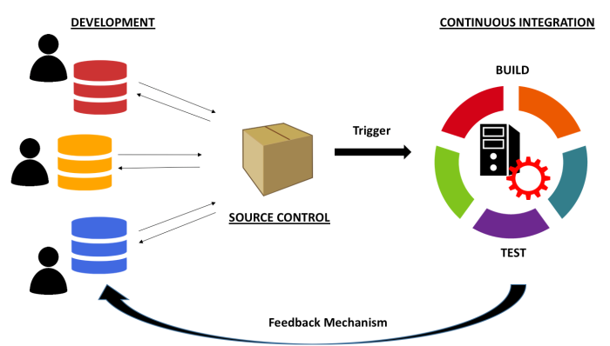

Continuous Delivery:

Means that artifacts are built and made ready to be deployed but they can not be deployed without a manual decision by a human being.

Continuous Deployment:

Implis that al th eprocess are automated, and a single commit triggers an automated pipeline that will eventually bring a new version of your application to the production environment without any human intervention.

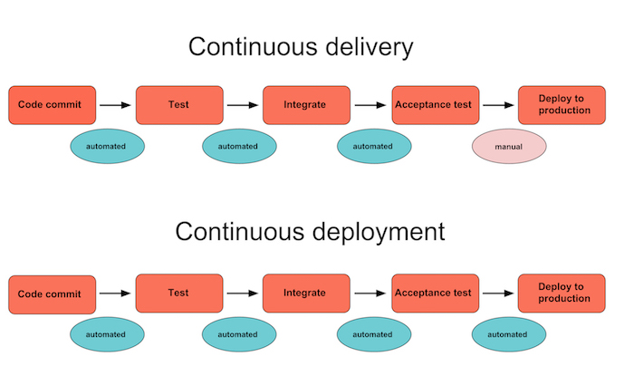

Ansible and chef, puppet

Container Tools:

Docker and Kubernetes.

Continuous Monitering:

Nagios Prometheus, Zabbex

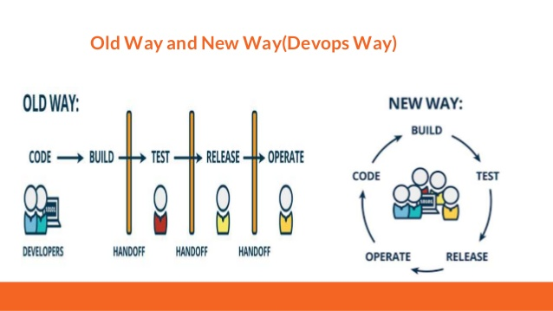

Agile & Contnuous Delivery:

